**Briefing :**

Our group task is to organize the talk show. And we are excited about organizing this show. Its goal is to **unlock human potential**. Our end goal is that after attending this show audience can have some **breakthroughs** in their life.

This project is all about a Platform where we invite **expert** speakers from all over **India**. who **share inspiring stories** or their **hard worked research** of their own. And what are the **obstacles** during the time they are following their **dream to achieve something** in their life? how they **overcame obstacles** to **achieve** their **dream** and make a **positive impact** in their communities. And the whole program (**show**) is being **recorded** so they are also available online for free on our website and YouTube channel. In addition to the talks, even if they haven’t attended the show anyone can watch it from anywhere in the world just by accessing the internet. We also organize such programs in 10 languages all over India.

This platform is developed iteratively using a **Spiral model** with a focus on continuous improvement based on audience feedback. sothat all upcoming shows can have improvement which can help in the long run. The development process involved **planning**, **risk analysis**, **Prototypes**, **evaluation**, and repeating the cycle to add new features and content based on feedback.

End of brief

**Type of software engineering model**

We have 5 types of software engineering models.

1. Waterfall model
2. Incremental model
3. Prototype model
4. Spiral model
5. Agile model

We also got more models such as

1. V-model
2. Rad model
3. Iterative model
4. Waterfall model

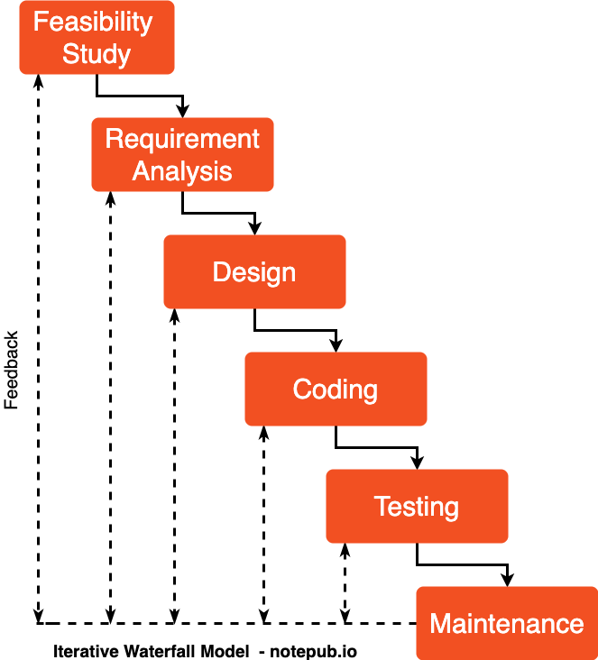

1. Incremental model

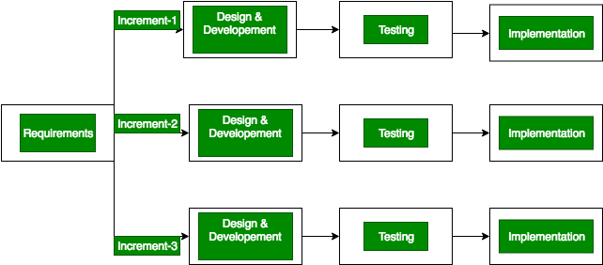

1. Prototype model

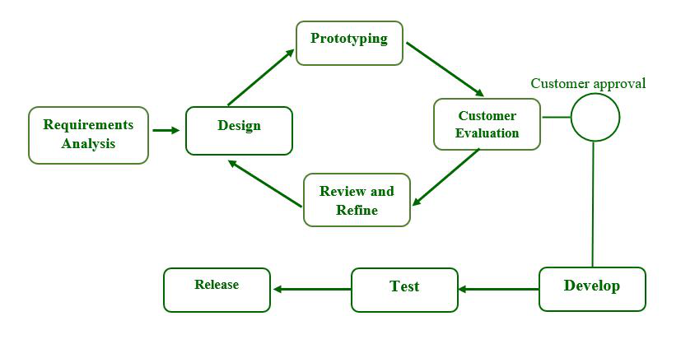

1. Spiral model

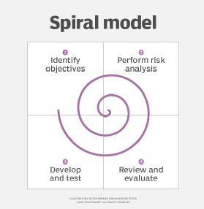

1. Agile model

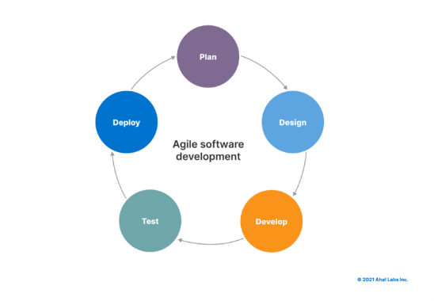

**We have three questions. (what, why, how) :-**

**What :**

We are using the **“spiral model”** because it’s suitable for this project in which we have to fulfill requirements that are: -

1. Large-scale project
2. Expansive and high budget
3. **Customer Satisfaction**
4. **Risk Handling**
5. **Unclear and complex**
6. **Change at any time**

**Why :**

In this project **“spiral model”** perfectly matches requirements such as **Unclear and complex** requirements, **expensive**, and **most important risk-handling**, and **customer satisfaction** all those requirements are fit for our talkshow.

That’s the reason why we choose it.

As you can see our project is **risk-based**. it has a risk at every moment such as if our spotlights are not working or our projector/mice/speaker are malfunctioning then we have to check it and we have to prepare for the worst-case scenario and also some backup plan.

**How :**

For this show, we have to consider the client’s requirements and fulfill his/her requirement which is a good show in our case where an expert’s speech can be helpful for every single attendee.

We also have to verify experts like if they have some achievements in their life if so we have to check their articles/research papers and if they have any other proof so we can have a legit person and not some con artist. This way we can have the risk of expert minimized.

Now, we have to move to the next step which is to check every risk factor for the experts We have to verify him/her background and next, we have to check the Seminar hall and other aspects of the Seminar hall we have to check emergency fire system, then projector / mice / speaker / spotlight / camera / security are malfunctioning if they are malfunctioning then we have to replace/repair them and we also have to prepare for worst-case and we have to prepare backup plane.

Now we have to implement these changes if we have any changes if we don’t we are good to go now during the show we have to constantly check if everything is working properly. and we can also arrange an audience question session where anyone can ask any questions related to the program of that day. we also have to get feedback related to the show so we can improve our next show and we have to keep this cycle going so our shows can improve rapidly.

**Conclusion :**

The conclusion is that if we keep using this spiral model our shows can keep improving themselves and we can reach more audience via this. So overall it’s best for our project.